**FYPJ Notes**

**Semester 3 Year 1**

**(Period 2)**

**Project Title:**

**Guided Tour Taskforce**

**Application**

**By: Tan Wei Jun, Terris**

**172737L**

**L308C06**

**Important Notes**

Project

* Guided Tour Taskforce Application
* SeatNo L308C06

Links

* [FYPJ Website](https://fypj.sit.nyp.edu.sg/fypj/) (Main Website)
* [AES Website](https://aes.sit.nyp.edu.sg/fypj/default.aspx) (Documentation)
* [Rubrics](https://outlook.office.com) (Pinned Email)

**27 May 2019 (Week 1)**

**27 May 2019 (Day 1)**

Today I read the link: [TIBCO Accelerators](https://community.tibco.com/wiki/accelerators?fbclid=IwAR3pCK3pKfH-vekr9aVmKRdZWEgGfb1APXgf9_6rmhMaTXX19zXxSDSB_mY#toc-2).

Then I surfed the web to learn more about IoT and IoT Accelerator.

[**TIBCO Community**](https://community.tibco.com/wiki/accelerators?fbclid=IwAR3pCK3pKfH-vekr9aVmKRdZWEgGfb1APXgf9_6rmhMaTXX19zXxSDSB_mY#toc-2)

* Accelerators
  + Connected Vehicles
  + FX Dealing
  + IoT Drilling
  + Apache Spark
  + Business Activity Monitoring
  + Risk Management
  + Real-Time Inventory
  + Case Management
  + Insurance Pricing
  + High Tech Manufacturing
  + IoT

[**IoT Accelerator**](https://community.tibco.com/modules/iot-accelerator)

**Overview**

The IoT Accelerator contains components to allow monitoring of sensor data from Internet of Things devices. Data feeds are validated and cleansed using configurable modules.

Customized business rules and entity featurization modules can be built using StreamBase and then attached to data feeds using configuration to capture real-time insights in the data stream. A web dashboard is provided to allow visualization of these activities and giving the opportunity to take action at critical business moments.

**Concepts**

**Devices** -- Anything that produces data. Also known as sensors. Typically produce data triplets at high frequency, consisting of a unique identifier, a timestamp, and a data value. Devices are attached to a single Entity, but an Entity can have multiple Devices.

**Entities** -- Anything else. This can be factories, production lines, equipment, aircraft, buses, ovens, drilling rigs... anything. Organized into hierarchies, one entity may have a single parent, but multiple children.

**Instances** -- Physical example of a Device or Entity, equivalent in object-oriented programming to an Object Instance. They are linked to a single Template, have a physical location, and a unique identifier like a serial number.

**Templates** -- Common properties for all Instances of a given Template, equivalent in object-oriented programming to a Class. May also be known as a type. Will not have a physical location or a unique identifier like a serial number (but could be a unique model number).

**Image Example**

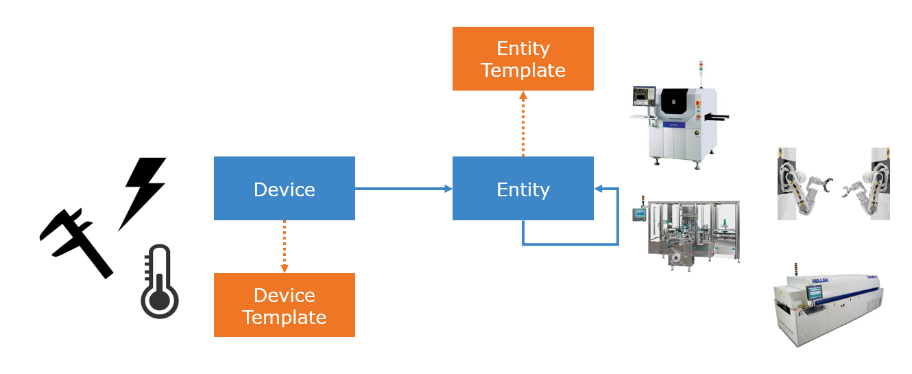

In addition, users can configure **Modules** which link to physical EventFlow application modules implementing specific business rules. These may be implemented as **Validation Modules**, **Cleansing Modules**, **Rule Modules**, and **Statistic Modules**. These modules are then linked to Devices and Device Templates so they are called during the processing of data from these data sources.

The accelerator captures data feeds from configured Devices as readings or summaries. It also captures data feeds for status and attribute changes, as well as part produced and part summary messages. Combining all this information together it computes metrics and publishes alerts in response to configured business rules.

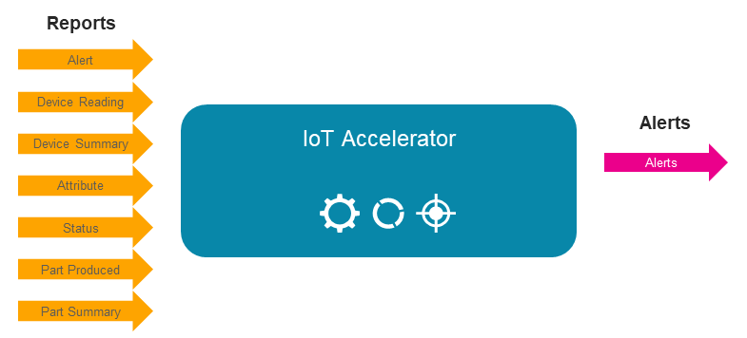

[**Read More…**](https://community.tibco.com/modules/iot-accelerator)

**Internet Of Things References (IoT)**

1. [**Top 6 Programming Languages for IoT Projects**](https://techbeacon.com/app-dev-testing/top-6-programming-languages-iot-projects)
2. [**TIBCO IoT**](https://www.tibco.com/solutions/internet-of-things)
3. [**IoT in Website Design and Development**](https://acodez.in/iot-website-design/)
4. [**7 IoT Existing Examples That Show the Power of IoT**](https://www.snyxius.com/7-internet-of-things-examples-show-power-iot/)
5. [**Why IoT loves Node.js**](https://internetofbusiness.com/iot-loves-node-js/)

**28 May 2019 (Day 2)**

Today I came to school late with MC.  
I got information on my project and proceeded to do the relevant installations.

First I downloaded the IoT Accelerator Demo codes [here](http://download.streambase.com/serve/Accelerators/IOT_2.1.0.zip).

Then follow the official installation guide for the IoT Accelerator [here](https://cdn.discordapp.com/attachments/312597667870146570/582837064383594496/Quick_Start.pdf).

Then download the relevant installation components:

**Java**

* JDK 1.8.0_181 & JRE 1.8.0_181 [here](https://filehippo.com/download_java_development_kit_64/86378/)
* ANT 1.10.5 [here](https://archive.apache.org/dist/ant/binaries/) (.zip)
* Maven 3.5.4 [here](https://archive.apache.org/dist/maven/maven-3/) (bin -> .zip)

**TIBCO – Integration (TIBCO_HOME_001)**

* TIBCO Enterprise Message Service 8.4.1 [here](https://edelivery.tibco.com/storefront/eval/tibco-enterprise-message-service-server/prod10929.html)
* TIBCO Patterns Search 5.4.0 [here](https://edelivery.tibco.com/storefront/eval/tibco-patterns-search/prod10340.html)

**TIBCO – Analytics**

* TIBCO Spotfire Desktop 10.0.0 [here](https://edelivery.tibco.com/storefront/eval/tibco-spotfire-desktop/prod10954.html) (The version is no longer available)

**TIBCO – Event Processing**

* TIBCO Streaming 10.4.0 (Including TIBCO Live Datamart) [here](https://edelivery.tibco.com/storefront/eval/tibco-streaming/prod11980.html)
* TIBCO Streaming AMS 1.4.0 (Same as above)

However, installation came to a halt when installations for the TIBCO components required a registered eDelivery account.

**29 May 2019 (Day 3)**

Today was quite an unproductive day.

I struggled a lot trying to figure if there was a free installation for the TIBCO Components. But there was none.

I was given my supervisor’s account, Mr Roy, and also attempted downloading with his account. However, the account had only access to a already paid 12 month subscription to TIBCO Spotfire. So I learned TIBCO Spotfire.

TIBCO Spotfire is a desktop application that enables users to create visualizations by providing a data source. I am currently using the browser version to do so.

**30 May 2019 (Day 4)**

Today I continued exploring the TIBCO Spotfire browser application. I learned how to connect data and create visuals with the data.

To connect a data source, you can either connect online or by browsing for a local file.

Known acceptable file types are Excel and databases. You have to test to find out more acceptable files types. Once connected, you can proceed to create visuals with the data. Visualizations include tables, bar charts, pie charts, scatter plot, and more.

The rest of the day was testing and exploring the platform with random datasets I found online. Free datasets are readily available at [https://data.gov.sg/](https://data.gov.sg/?fbclid=IwAR17vAYZ8crTYC7hmt5PQvDarHtxB5O9g0cpsI9TDjQnaIH4YiQ3BL5-kRs) .

Note To Self: For more detailed information, go to other Google Doc.

**31 May 2019 (Day 5)**

Continue exploring Spotfire today. Learned the different visualization types. For each of this visuals, I also tested and explored their “Property” setting to discover ways to manipulate and utilize them.

**3 June 2019 (Week 2)**

**3 June 2019 (Day 6)**

Had a long review with my supervisor on the progress and update of the work. Through the talk, he suggested that I create slides where I explain in depth on how a certain trend may suggest certain results, with a proper 4 step approach to analysing trends in data.

Also suggested that I remodel parts of the TIBCO Spotfire project to allow better usability such as filters. Explore the other database file types. Learn Windows Form. Think of use cases for the listed IoT options on Facebook chat.

**3 June 2019 (Day 7)**

I updated a little on the TIBCO Spotfire. Then I moved to creating an application that converts databases to a Excel sheets. Still work in progress. The application is made with C#, Visual Studio. Project type: “Windows Forms”. .NET Framework Version 4.6.

**4 June 2019 (Day 8)**

With the start of development of a new application, comes problems and issues. I had to learn how and what I’ll be dealing with in the next few days. Today specifically, I struggled a lot in trying to find a suitable code template to connect the SQLite into the Windows Forms project.

**5 June 2019 (Holiday)**

**6 June 2019 (Day 9)**

Continued the Windows Forms and managed to fix the connection problem. Finished adding few convenient features to allow a more user friendly experience, and better interactivity/flow for normal human beings to use.

**7 June 2019 (Day 10)**

Made final touches to the project. Now started to do documentation for this finished mini project. Currently, the project has no known bugs, and is ready for use to do TIBCO Spotfire.

**10 June 2019 (Week 3)**

**10 June 2019 (Day 11)**

Made a few sample analysis with the Open House Day 1 and Day 2 Database in TIBCO Spotfire, and made some improvements in the aesthetics of data.

**11 June 2019 (Day 12)**

Updated the TIBCO Spotfire analysis for Open House Day 1 & Day 2 Database. Had a meeting with supervisor to discuss on what I will be doing for the next week.

Things to do in the next one week:  
1. Improve SQLite to Excel Application (UI and file destination)

2. Better visuals for TIBCO Spotfire

3. Work on IoT equipment and practice using them.

**12 June 2019 (Day 13)**

Through much exploration in TIBCO Spotfire, I discovered that the database provided has problems with the time data types. They are registered as numbers as opposed to time. Eg. 1100, 1130, 1200, 1400.

Hence, today I did some updating to the Windows Forms application to hopefully enable the feature to select which table columns to change to date time.

**13 June 2019 (Day 14)**

Finished and fixed all bugs for the new changes to Windows Forms Application. Researched more on TIBCO Spotfire.

Found out that there was a desktop version and a web client version (Cloud) (Been using this for the past 3 weeks). Tried exploring the desktop version.

Did a lot of research about TIBCO Spotfire as a whole. Tried to learn and understand all the different terms and Spotfire versions available. Can be seen in another Google Doc.

**14 June 2019 (Day 15)**

Started on the attempt 2 of a new analyses on Open House 2019 database. Made simple visuals.

**17 June 2019 (Week 4)**

**17 June 2019 (Day 16)**

Improved on the visuals and did minor research.

**18 June 2019 (Day 17)**

MC - NS enlistment screening

**19 June 2019 (Day 18)**

Finished the visuals and made adjustments to the documentation.

**20 June 2019 (Day 19)**

Started on making the SpotfireDemo App in Windows Forms. Development came into many problems due to much uncertainty and doubts about the usage of available tools.

Managed to use a webbrowser controller to produce a working demo, however it lags with delays in responsiveness.

**21 June 2019 (Day 20)**

Meeting with supervisor to talk about expected work to be done the following week, and how to move on from where I am.

Suggested to explore more on the Spotfire Demo. There I managed to produce a working app through a workaround as only APIs offered were JavaScript API.

(Not supported in Windows Forms)

The workaround is to use a live database instead, where the app will communicate with the database then to the Spotfire App.

**24 June 2019 (Week 5)**

**24 June 2019 (Day 21)**

Today, I ventured forth into using a live database as the connecting tool between my SpotfireDemo App and Spotfire App. I came across many confusing concept, bugs, fixes, and concepts that are important to note down for documentation. Hopefully, I will be able to note all of them properly, and orderly.

Bugs mostly pop-up when trying to run both the Demo App and Spotfire App on another computer system due to (localdb)MSSQLLocalDB error. This error popups up due to the hosted database being only local, and does not share on different devices as an unauthorized error will appear.

**25 June 2019 (Day 22)**

Did a small research on ideas for some IoT analysis. The IoT data analysis must be easily obtainable with the available IoT sensors, and be able to create the visuals in Spotfire. I compiled a list of tables of ideas for the IoT analysis.

Then made follow up adjustments and testing between the SpotfireDemo App and Spotfire, between school desktop and personal laptop. Then continued to on documentations.

**26 June 2019 (Day 23)**

Attempted doing Raspberry Pi with Visual Studio 2015. However, unable to get it to work. The Visual Studio version is different as it requires VS 2015 w/ Update 3. Then, it requires the “Universal Windows App Development Tools” which are of different versions. This caused many technical difficulties in trying to install it into the school desktop. Also, NYP disables certain downloading websites between 9am - 6pm. Personal Laptop have to do the same as well.

**27 June 2019 (Day 24)**

I spent the entire day practicing with the Raspberry Pi with Visual Studio Background Application (IoT) project. I spent most of the time solving an errors to configure the IoT libraries into the project.

**28 June 2019 (Day 25)**

Today, I finished making a basic demo for the IoT project. I have created a Background App (IoT) connecting to my Windows Forms App. They work well, although not all applicable sensors have been added.

**1 July 2019 (Week 6)**

**1 July 2019 (Day 26)**

Continued making the IoT. Finished making all sensors except card reader.

**2 July 2019 (Day 27)**

Improved UI for all my demo applications

Made huge changes to IoT code structures, database design, and flow of the program.

**3 July 2019 (Day 28)**

Checked and improved each visualisation for each analysis on Spotfire

Added auto reload. Buggy.

**4 July 2019 (Day 29)**

Preparing presentation notes

**5 July 2019 (Day 30)**

Finished Mid-Term Presentation. Starting to update documentation of all work so far.

**8 July 2019 (Week 7)**

**8 July 2019 (Day 31)**

Finished documentation for entire SpotfireDemo. Documentation includes the FruitStore Demo and IoT Discussion Room Booking Demo, IoT Background Application, and TIBCO Spotfire integration/configurations.

**9 July 2019 (Day 32)**

Continued on documentations. Decided to split the TIBCO Spotfire documentation into 2 documents. Each document for each Spotfire version, web client and desktop app.

Finished documentation for TIBCO Spotfire introduction and TIBCO Spotfire Desktop App

**10 July 2019 (Day 33)**

Attempted making the 3rd round of OH 2019 Visualisation but came into problems. As following request, the data in the database have anomaly human errors. I am now required to also clean these errors and make a report of it.

**11 July 2019 (Day 34)**

Started making a report for the errors residing in the OH 2019 database

**12 July 2019 (Day 35)**

Am still correcting the data in the OH 2019

**15 July 2019 (Week 8)**

**15 July 2019 (Day 36)**

Correcting data in OH 2019. Found new sets of errors.

**16 July 2019 (Day 37)**

Sick MC

**17 July 2019 (Day 38)**

Started making visualisations with whatever data that is corrected so far, then moved to continue cleaning the OH 2019 database.

**18 July 2019 (Day 39)**

Cleaned OH 2019 database.

**19 July 2019 (Day 40)**

Finished making OH 2019 visual for tour stop duration. With the realisation of previous known errors, I have decided to redo portions of the OH 2019.

Officially now, I have done the following, which is cleaned all known errors in data, and then finally added the new columns for calculating the duration of each stop. The duration of each stop required to first organise the Tour_Stop_Histories, then sort the data based on Route, Stop, Tour Batch..

The sorting will give an easier time adding the new columns which is the finding the next tour stop time to use as the Stop_End_Time. Then finally calculating the duration. These data is then used for Spotfire to present each of the individual stops, and the average duration of each stop.

There are still certain data yet to be cleaned as it contains too many discrepancies. Such as wrong timestamp, missing Time End. and even more unknown data discrepancies.

Then I finished the visualisations for the Spotfire with the new cleaned database, with reports completed as well for discrepancies.

**22 July 2019 (Week 9)**

**22 July 2019 (Day 41)**

Started and finished making a simple Spotfire Demo for multilingual with WinForms + Spotfire.

Currently supporting: English, Chinese, Russian.

**23 July 2019 (Day 42)**

Explored the TIBCO Messaging. Messaging Mosquitto (MQTT) doesn’t seem to be able to setup. And so proceeded the exploration of TIBCO Enterprise Messaging (EMS) Community Version.

It uses Command Line Interface (CLI) to use the software. Managed to find a free external GUI called Gems that works with the EMS. Have to explore further the new termerlogies EMS uses to store data.

**24 July 2019 (Day 43)**

Explored a lot of alternatives for a cloud database for this project.   
  
Confirmed that TIBCO EMS and ThingSpeak will not be using because it is not supported by Spotfire.

Other free cloud databases not appropriate are <https://www.freesqldatabase.com/account/>.  
Microsoft Azure is too short in free time, hence not great tool.  
Google BigQuery has usage limit renewed every month, listed for exploration,.

AWS RedShift is listed to explore as well, then compared with BigQuery to see which is better.

Ideally: Free account which has no expiry so that we can use them for further projects/curriculum or demo. Some free acc expires after a year and is not suitable to create a demo out of it.

**25 July 2019 (Day 44)**

Started development on a demo for the BigQuery cloud database usage. Currently, everything is complete except for the language feature.

**26 July 2019 (Day 45)**

Today I finished developing the demo for BigQuery, and am doing documentation for it. Next will be a demo for RedShift then to compare their usability and their free trial periods for school use.

**29 July 2019 (Week 10)**

**29 July 2019 (Day 46)**

Trouble using AWS Redshift. Could not resolve the problem and shifted to using AWS RDS instead, using the Microsoft SQL Server option. However, the same problem occurred.

**30 July 2019 (Day 47)**

Today, fixed the error of the connection between AWS Cloud databases to external applications.

**31 July 2019 (Day 48)**

The error appeared again. With more research, I found out that the reason behind the error was due to the school WiFi blocking the port endpoints required to use the database.

Installed a bunch of software, to see if can fix the issue.

**1 August 2019 (Day 49)**

Tested with different endpoint ports to connect without VPN. Was not able to.

Settled on using VPN to do the connection between AWS Cloud database and external applications. Stated doing the WinForms demo for AWS.

**2 August 2019 (Day 50)**

Finished AWS demo, met with supervisor to talk about the work ahead.

**5 August 2019 (Week 11)**

**5 August 2019 (Day 51)**

A

**6 August 2019 (Day 52)**

A

**7 August 2019 (Day 53)**

A

**8 August 2019 (Day 54)**

A

**9 August 2019 (Day 55)**

A

**29 July 2019 (Week 12)**

**12 July 2019 (Day 56)**

A

**13 July 2019 (Day 57)**

A

**14 July 2019 (Day 58)**

A

**15 August 2019 (Day 59)**

A

**16 August 2019 (Day 60)**

A